In this experiment you will see a series of circles appear briefly on the screen. These are the cue circles. They will not always be colored blue.

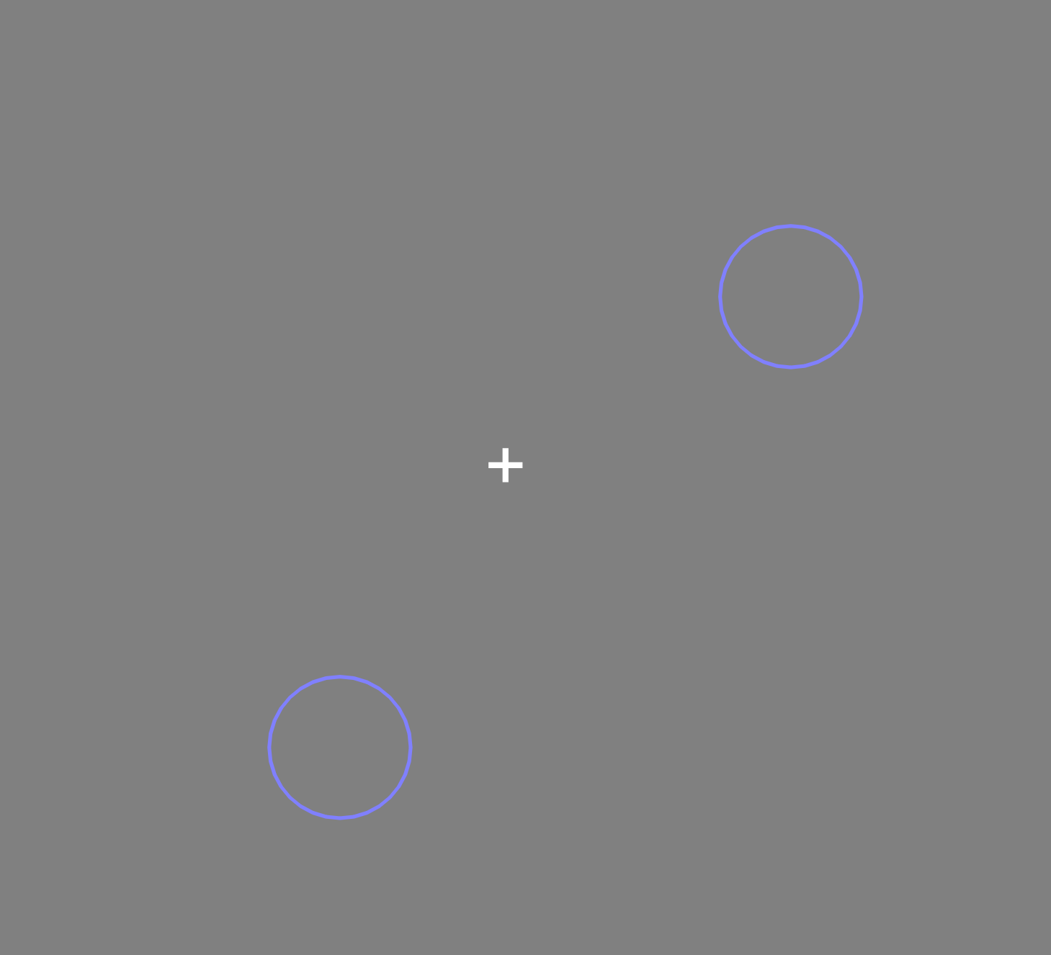

The cue circles will disappear and then new circles, one containing a letter “T” and one containing a letter “I,” will appear. You must respond to the orientation of the letter “T” using the arrow keys on the keyboard.

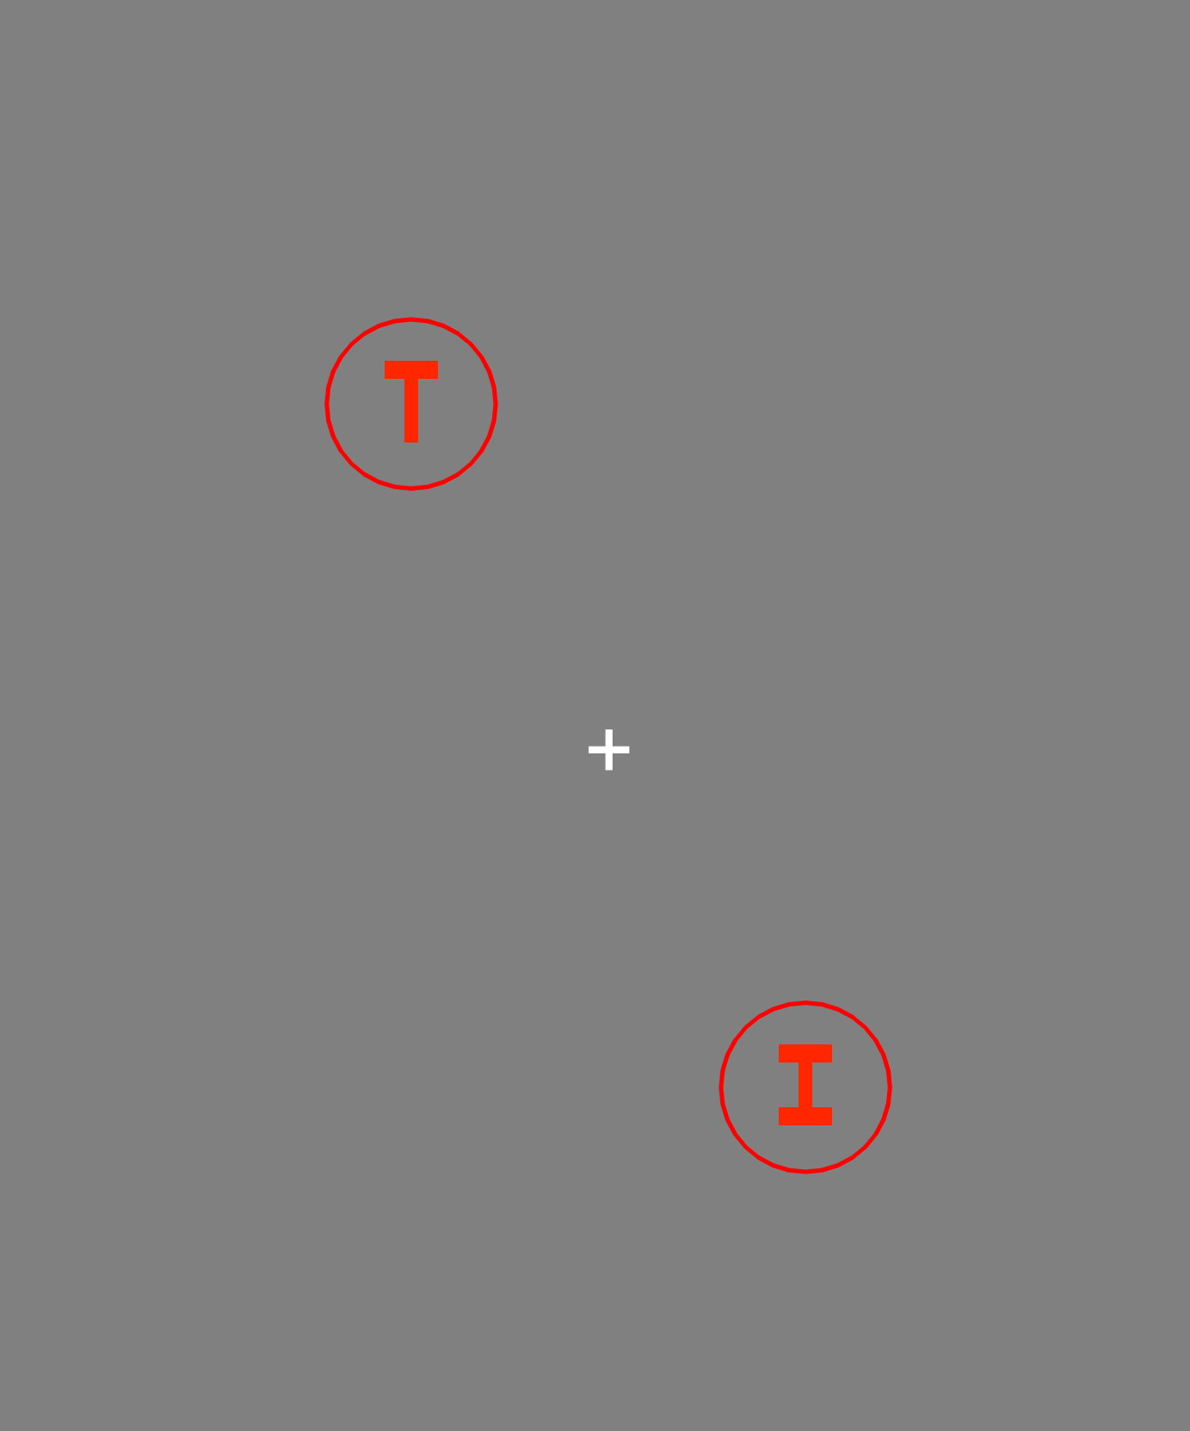

You should press the “up” arrow key when the “T” is oriented right-side-up. You should press the “right” arrow key when the “T” is rotated 90 degrees to the right. You should press the down arrow key when the “T” is rotated 180 degrees, i.e. when it is upside-down. You should press the left arrow key when the “T” is rotated 90 degrees left. You should NOT respond to the orientation of the letter “I.”

There are 3 different types of cue circles. “Target” cue circles indicate where the “T” is likely to appear. “Distractor” cue circles indicate where the distracting “I” is likely to appear. “Neutral” cue circles are non-informative, meaning that they do not give you meaningful information as to where the T or I will appear. Target and Distractor cues will be correct on 80% of trials in some blocks, and will be correct only 50% of trials in other blocks. You will always be informed what the cue type and % accuracy of the cue is for the block before you begin.

When given target cues, you should try to maintain, or remember, both cue locations in mind in anticipation of the target “T.”

When given distractor cues, you should try to ignore the cue locations, since that is where the distracting “I” might appear.